**Royal Docks Enterprise Zone Programme Board**

**Board Membership**

**Recruitment Pack**

**October 2024**

Dear Applicant,

**Membership of the Royal Docks Enterprise Zone Programme Board**

Thank you for your interest in becoming a Member of the Royal Docks Enterprise Zone Programme Board.

This Recruitment Pack provides you with information on the Board’s role and responsibilities and details about the application process for the role of a Member.

For a confidential discussion about the positions, please contact Daniel Bridge

[Daniel.bridge@royaldocks.london](mailto:Daniel.bridge@royaldocks.london).

We look forward to receiving your application.

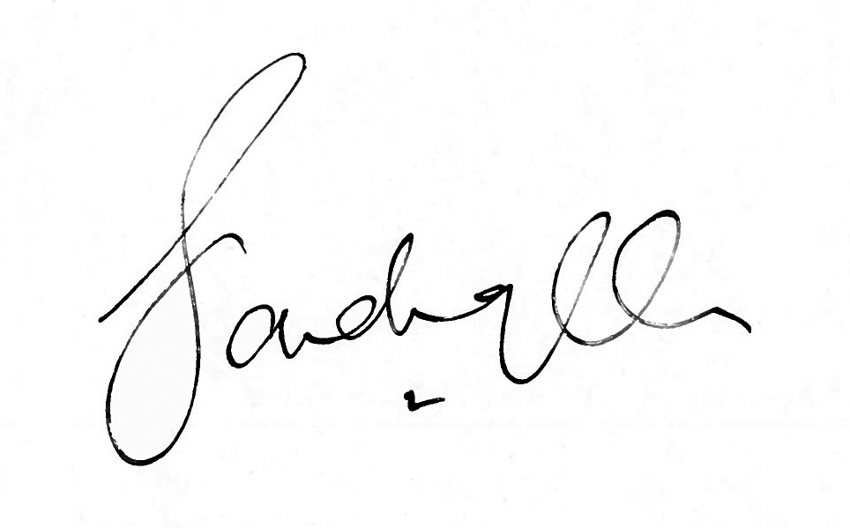Yours sincerely,

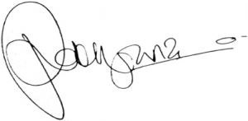

**Sadiq Khan Rokhsana Fiaz OBE**

Mayor of London Mayor of Newham

**Contents**

1. **Introduction**
2. **About the Royal Docks Enterprise Zone Programme Board**
3. **Membership and Governance**
4. **Role Specification**
5. **Appointment Details**
6. **Appointment Process**

|  |  |
| --- | --- |
| **Role:** | Board Member x 3 |
|  |  |
| **Time Commitment:** | 2-4 hours on a quarterly basis |
|  |  |
| **Start Date:** | Expected to start from January 2025 |
|  |  |
| **Duration:** | Initial 2-year term (option for another 2-year extension based on good governance practices) |
|  |  |
| **Appointment:** | Appointment by the Mayor of London |
|  |  |
| **Location:** | City Hall (Royal Victoria Dock) and Newham Dockside (Royal Albert Dock) |
|  |  |
| **Expenses:** | Eligible for remuneration and expenses (see remuneration section below) |

1. **Introduction**

This is an exciting opportunity to shape the next stage of the Royal Docks by joining the Royal Docks Enterprise Zone Programme Board, co-chaired by Rokhsana Fiaz OBE, Mayor of Newham and Tom Copley, Deputy Mayor of London for Housing and Residential Development.

The Royal Docks is one of London’s largest regeneration and investment opportunities, at the centre of an expanding east London region. Once the UK’s gateway to world trade, today the Royal Docks is re-emerging as a major new business and visitor destination, with approximately £5 billion worth of investment planned over the next 20 years, delivering up to 36,000 new homes, 55,000 new jobs and up to 4 million square feet of commercial space.

We are looking to appoint three Members with expertise in one or more of the following:

* economic growth, property development and inward investment
* the night-time economy, retail and hospitality
* social infrastructure and transport connectivity
* environmental sustainability
* cultural placemaking
* marketing and communications
* community engagement.

We are absolutely committed to better representing the diverse communities we serve in east London and are looking for people who share this passion. We’re keen to hear how your work and lived experiences make you suitable for the role of board member, and we’d especially welcome applications from people based in our local communities, and those from traditionally underrepresented groups. Above all, we want to understand how you will give us a better representation of the perspectives of those we are here to serve, and how you can help us to continuously support and develop our inclusive culture.

We are particularly interested in applicants who live or work in east London from the business, voluntary or community sectors, including a prominent member of the Newham business community.

We strongly welcome and encourage applications from individuals who identify as female, come from culturally diverse backgrounds, or have a disability.

1. **About the Royal Docks Enterprise Zone**

The Royal Docks is one of the largest regeneration areas in London, with seven significant developments being brought forward across 175 hectares of public land belonging to the Greater London Authority (GLA), representing a mix of residential, commercial, and industrial developments. Approximately £5 billion of investment is planned for the area over the next 20 years.

The area’s designation as an Enterprise Zone (EZ) has helped unlock significant public-sector investment and the establishment of a dedicated Royal Docks delivery team that is helping to coordinate the area’s comprehensive redevelopment.

Over the last five years, the Mayors of London and Newham have jointly been delivering a comprehensive regeneration programme that will restore the former docks into a thriving, new waterside destination.

This includes more than 9,000 new homes built or under construction; 40,000sqm of commercial space completed with another 25,000sqm under construction; approximately 2,620 new jobs created; £37.4 million invested across more than 20 public realm projects improving the quality and sense of place; over 270 cultural projects produced, attracting over 300,000 attendees; and the establishment of the Royal Docks as a Living Wage place, where a growing number of employers have signed up to paying a fair wage.

The Mayor of London and Mayor of Newham launched the new five-year Royal Docks Delivery Plan on 7 March 2024 with an overall investment of £64.31 million (£21.58 million revenue and £42.73 million capital) to be delivered in the area over the five-year delivery period. The plan is structured around three strategic outcomes:

* **Prosperity, Growth & Investment**   
  The Royal Docks will become an established economic stronghold for London, home to a diverse mix of businesses and industries. The area’s growing commercial offer and innovation ecosystem will attract new investment, enable entrepreneurial activity, and create local skilled jobs.
* **Sustainability & Wellbeing**   
  The Royal Docks will lead the way in sustainable investment and development, with six distinct waterside neighbourhoods that provide resilient, happy, healthy places for nature and residents to flourish.
* **Culture & Community**   
  Building on the area’s existing communities and growing cultural ecosystem, the Royal Docks will evolve as London’s Cultural Engine. New public spaces, waterfront and cultural amenities, and affordable creative and production workspaces, will make the Royal Docks one of the most exciting and varied places in London to live, work and play.

Further information on the latest delivery plan can be found here: [The 2024-2029 Royal Docks Delivery Plan.](https://www.royaldocks.london/articles/delivery-plan)

1. **Membership and Governance**

The Royal Docks Enterprise Zone Programme Board is a partnership board between the London Borough of Newham and the Greater London Authority. It comprises of up to eight members, including Trade Union Representation, and is co-chaired by Rokhsana Fiaz, Mayor of Newham, and Tom Copley, Deputy Mayor of London for Housing and Residential Development.

The Board provides strategic direction to the Royal Docks Team and drives forward regeneration and economic growth opportunities within the Royal Docks. It is also responsible for monitoring the implementation and delivery of the Royal Docks Delivery Plan and making recommendations on the allocation of funding generated by the uplift in business rates receipts through HM Government’s Enterprise Zone business rates retention scheme.

**New Board Membership Composition**

The future structure of the Royal Docks Enterprise Zone Programme Board will comprise the following eight positions:

|  |  |
| --- | --- |
| **Members** | **Role** |
| Mayor of Newham | Co-Chair |
| Deputy Mayor of London for Housing and Residential Development | Co-Chair |
| Trade Union Representative | Board Member |
| Local Ward Councillor from Newham | Board Member |
| 3 new representatives covering the three outcomes | Board Member x 3 |
| A young person representative from the local area | Youth Board Member |

# Role Specification

**The role**

We are seeking to appoint three Members to the Board who, collectively, will bring expertise in all three strategic outcomes. Members must have a deep understanding of the opportunities and challenges associated with achieving these outcomes.

**Duties**

* Attend and contribute to quarterly Board meetings, having prepared appropriately. Meetings are usually held quarterly;
* Attend and contribute to any sub-groups as assigned;
* Provide leadership and strategic direction to the Royal Docks Team and drive forward regeneration and economic growth opportunities within the Royal Docks;
* Oversee the implementation of the Royal Docks Delivery Plan and monitor the delivery and performance of the Royal Docks Team;
* Contribute to the development of strategies, policies and plans, including taking a role in developing a long-term vision for economic development across the Royal Docks;
* Ensure that the Board, in reaching decisions, acts consistently with the GLA’s statutory obligations and the GLA’s decision-making framework;
* Promote a high standard of decision making and oversight of the administration of any funds distributed by the Board including retained business rates in the Royal Docks Enterprise Zone;
* Ensure that the diversity of London’s communities and economy is reflected in the work of the Board; and
* Represent the Board and act as an ambassador for the Mayor and London.

**Criteria**

To fulfil the role of Member, applicants will have:

* Senior and substantial experience in their relevant sector;
* An ability to contribute effectively in developing strategy;
* An ability to drive improvement in the delivery and implementation of the five-year delivery plan;
* High level experience of representing and/or influencing bodies;
* An ability to represent the Mayors of London and Newham and the Board effectively to external stakeholders;
* An ability to act as a conduit between the Board and their respective professional communities;
* An ability to engage the confidence of the Mayors of London and Newham and represent their vision, values and objectives; and
* The capacity to contribute analysis and insight at different scales: regional, pan-London and local.

**Profile of successful candidates**

We are looking to appoint three Members with expertise in one or more of the following sectors:

* economic growth, property development and inward investment
* the night-time economy, retail and hospitality
* social infrastructure and transport connectivity
* environmental sustainability
* cultural placemaking
* marketing and communications
* community engagement

Our ambition is that each appointee will particularly champion progress against a key outcome most relevant to their background:

**Prosperity, Growth & Investment**

We are looking for someone with experience in the strategic development, design, and implementation of high-profile economic development programmes. This would include knowledge of inward investment, employment and skills, business support initiatives, sector specialisms (such as Tech or the Creative Industries) and building area-based regeneration in partnership with a range of people and bodies. You will have a proven track record of creating enabling environments for business growth and fostering conditions that support the expansion and sustainability of businesses. Experience in attracting investors and/or developing place-investment strategies is also essential, ensuring that the area remains competitive and appealing to both domestic and international investors.

**Sustainability & Wellbeing**

We are looking for someone with significant experience of regeneration or property development, including the management of large projects from initiation to completion. Significant experience with sustainable development and an understanding of the principles of place-making are essential. You will also bring experience in collaborating with a diverse array of partners and communities to achieve these aims. Our ambition is for the Royal Docks to lead the way in sustainable investment and development, with six distinct waterside neighbourhoods that provide resilient, vibrant, and healthy places, where both nature and residents can thrive.

**Culture & Community**

From fostering the Royal Docks organic cultural offer and community participation, to attracting large-scale events and animating key sites, your challenge is to support us in positioning the Royal Docks as a distinctive cultural and commercial destination through the strategic development and implementation of marketing and communications plans and a complex cultural place-making programme. This will include working in partnership with a diverse stakeholder group to attract local, national and international audiences. We are looking for someone with significant experience at a senior level within a high-profile context, with a proven track record in the delivery of complex cross-organisational projects. This should ideally include the leadership of politically sensitive strategic programmes and events, and a track-record in delivering a sponsorship or fundraising income stream.

We are particularly interested in applicants who live or work in east London from the business, voluntary or community sectors, including a prominent member of the Newham business community.

London's diversity is its biggest asset, and we strive to ensure our workforce reflects London's diversity at all levels. We welcome applications from everyone regardless of age, gender, gender identity, gender expression, ethnicity, sexual orientation, faith, or disability.

We strongly welcome and encourage applications from individuals who identify as female, come from culturally diverse backgrounds, or have a disability.

The successful candidates will be the individuals who best meet the criteria listed in the role specification above and have relevant expertise or understanding of one or more of the sectors identified above.

# Appointment Details

**Time Commitment**

The Board meets quarterly, and meetings generally take place in the Royal Docks, either at Newham Dockside or City Hall. In addition, successful candidates may be asked to join a sub-group and represent the Board at events.

**Remuneration and Expenses**

Members may be able to claim a stipend of £50 per hour. This applies to those who are unemployed, freelance, in education, in part-time employment, in full-time employment with a micro enterprise (fewer than 10 employees) or on the National / London Living Wage.

Each meeting will last up to two hours, with an additional two hours allocated for preparation. Therefore, Members can claim up to £200 per meeting.

To receive payment, Members will be put on the payroll of Reed employment agency. Please note that we cannot advise on how payments may affect individual Members’ benefits or tax liabilities. We strongly recommend seeking guidance on this before claiming a stipend. The responsibilities of Members are the same, regardless of whether or not they claim a stipend.

Additionally, Members are entitled to reimbursement for reasonable travel expenses incurred in the performance of their role, in line with the GLA’s Expenses and Benefits Framework.

**Term of the Appointment**

The term of the appointment will be specified by the Mayor but is likely to coincide with the current London Mayoral term, which ends in May 2028. The appointment will be structured as an initial two-year term, with an option for a two-year extension based on good governance practices.

**Start Date**

Appointees are expected to be available to take up their role from January 2025.

# Appointment Process

Following assessment of applications against criteria for appointment, shortlisted applicants will be interviewed by a selection panel. The panel will make recommendations for appointment to the Co-Chairs of the Board.

The GLA promotes an equal opportunities policy. Appointments are made on merit following a fair and transparent process and are governed by Nolan principles and the Mayor of London’s protocol on appointments. Please view our [Protocol on Mayoral appointments](https://www.london.gov.uk/sites/default/files/mayoral_appointments_protocol_october_2015.pdf) for further details.

The Mayor of London will confirm appointments to the Board.

**How to Apply**

Candidates are invited to apply by submitting a CV and cover letter of no more than 1500 words **via our online recruitment system**.

The CV must include details of employment, public appointments, directorships and qualifications; the name and contact details of two referees; and any relevant information regarding eligibility for appointment.

The cover letter should provide details of the relevant experience that equips you to serve as a Member of the Royal Docks Enterprise Zone Programme Board, addressing the criteria listed in the role specification.

Please visit: [www.royaldocks.london](http://www.royaldocks.london) for further information and to apply online.

For a confidential discussion about the positions, please contact Daniel Bridge

[Daniel.bridge@royaldocks.london](mailto:Daniel.bridge@royaldocks.london).

**The closing date for submission of applications, including the recruitment monitoring form, is Sunday 10th November 2024 at 23:59 GMT.**

# Thank you for taking the time to apply for this role. All data will be processed in accordance with the provisions of the Data Protection Act.